**Tugas Praktikum   
Pemrograman Berorientasi Objek**

“Tugas 09 Nested Class – Anonymus Inccer Class*”*

**Kelas A**



Oleh :

Muhamad Ihsan Setiawan

4523210069

Dosen :

**Adi Wahyu Pribadi**

**S1 Teknik Informatika**

**Universitas Pancasila**

**2024/2025**

**Library.java**

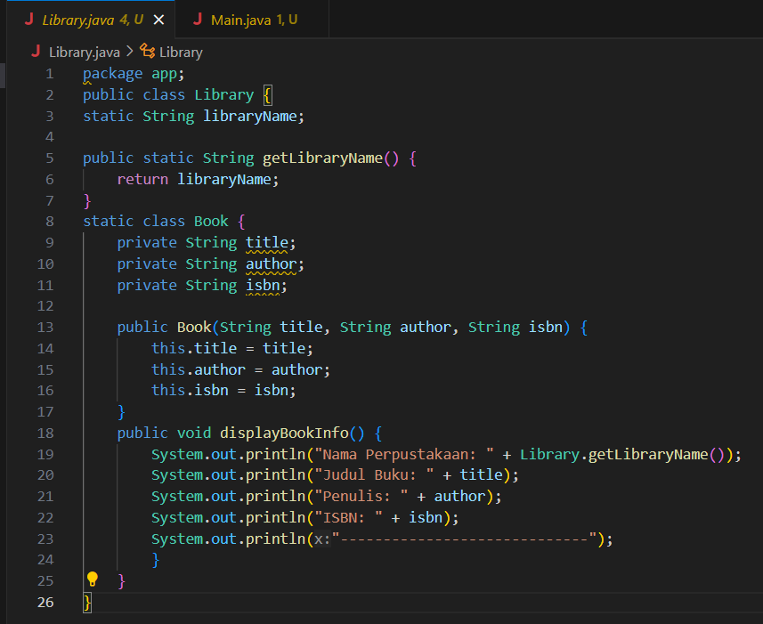

**Main.java**

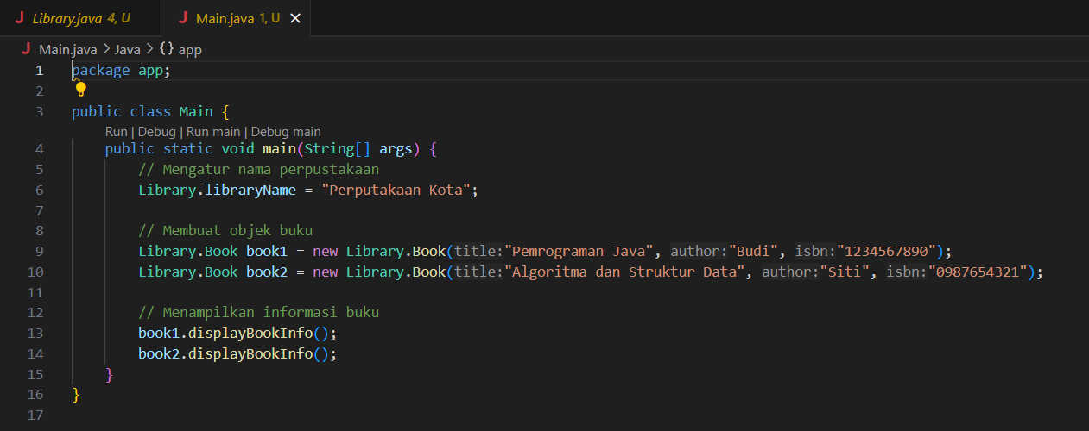

**Output**

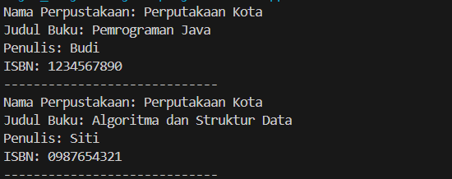

**ATM.java**

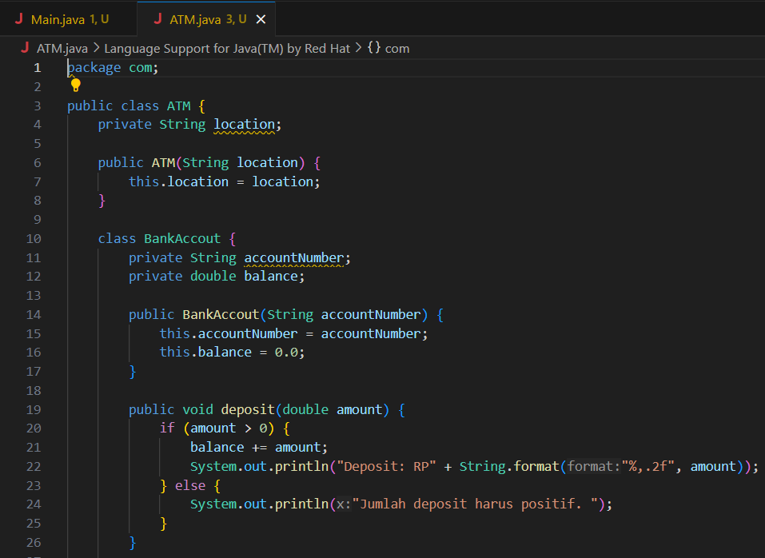

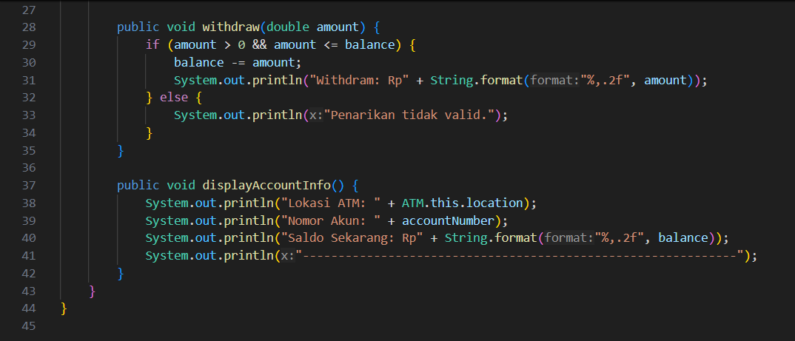

**Main.java**

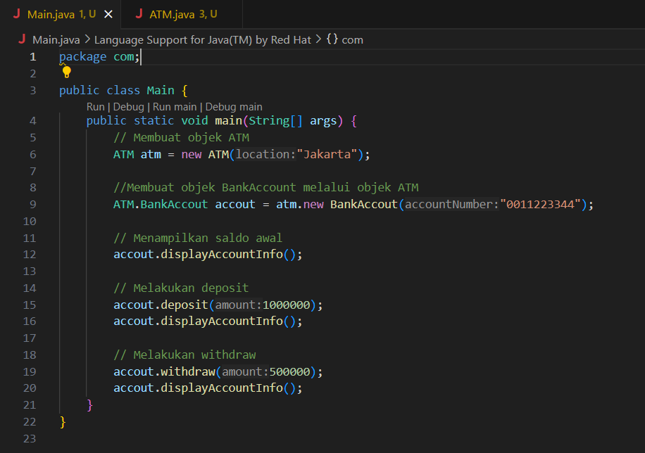

**Output**

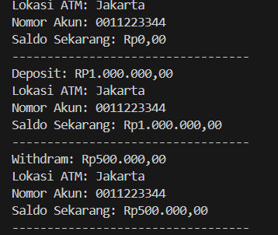

**FactorialCalculator.java**

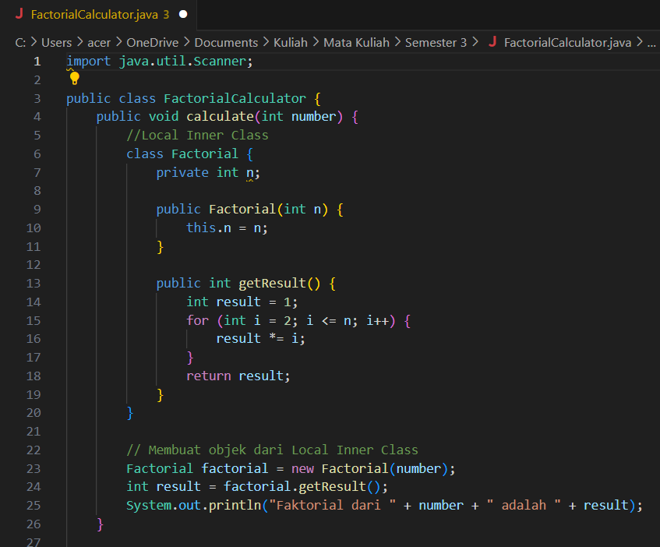

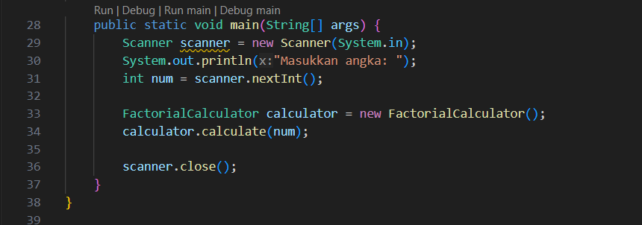

**Output**

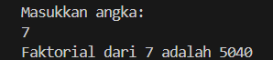

**Anonymous Inner Class**

**SimpleTimer.java**

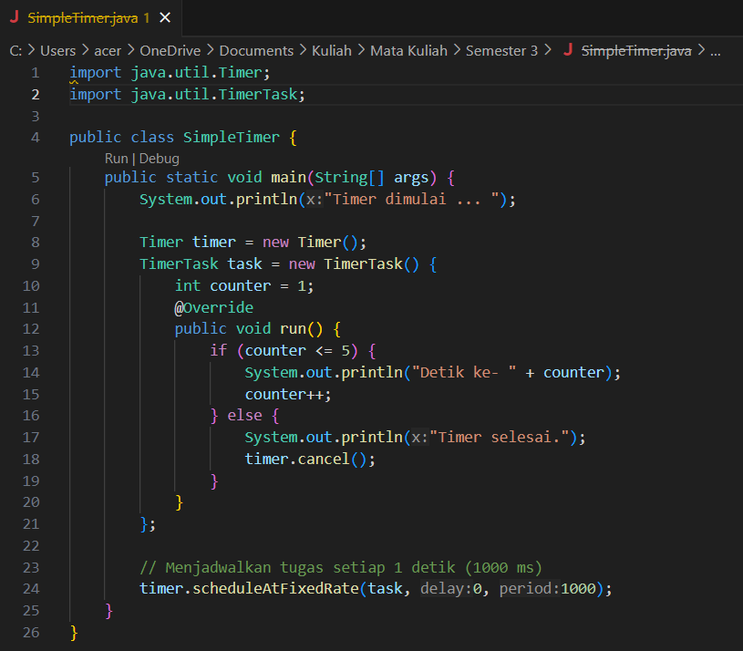

**Output**

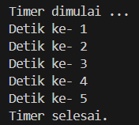

**Link GitHub:** https://github.com/icen6/Tugas-Praktikum-PBO.git